Design one detailed test case:

Reset a password should work

1. Go to “*Anmelden*” screen (<https://www.shop-apotheke.com/nx/login/>) and enter the valid E-Mail address   
   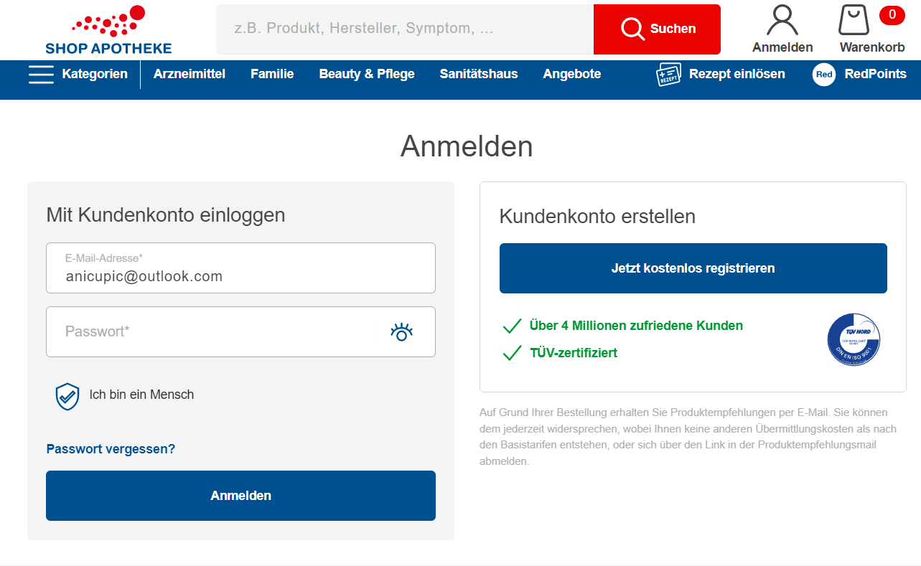
2. 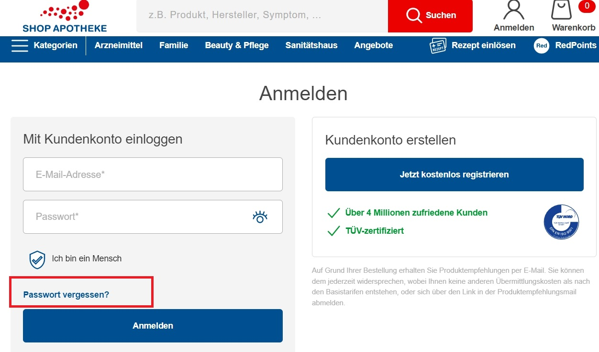Click on “*Passwort vergessen?”*

1. 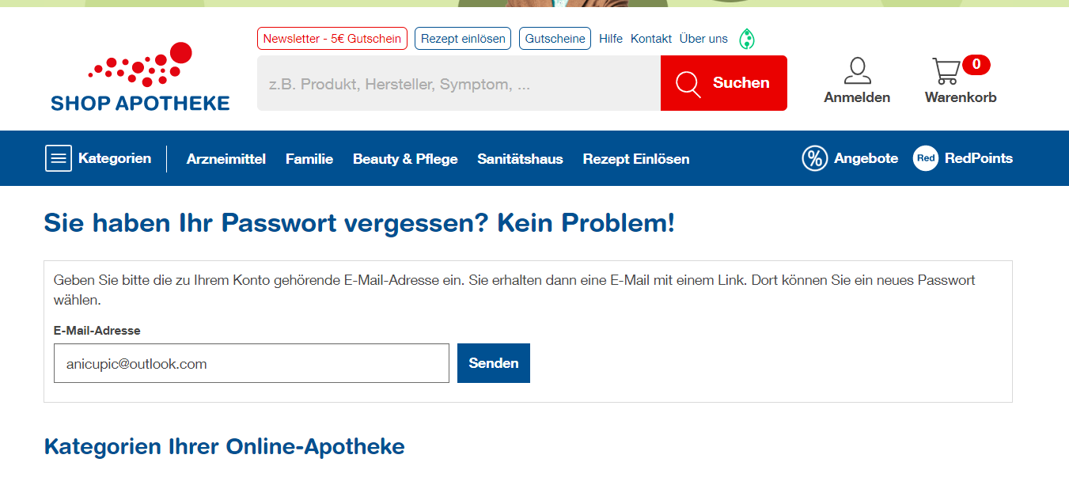User is redirected to the following screen – enter again the correct email and click on button “*Senden*”
2. 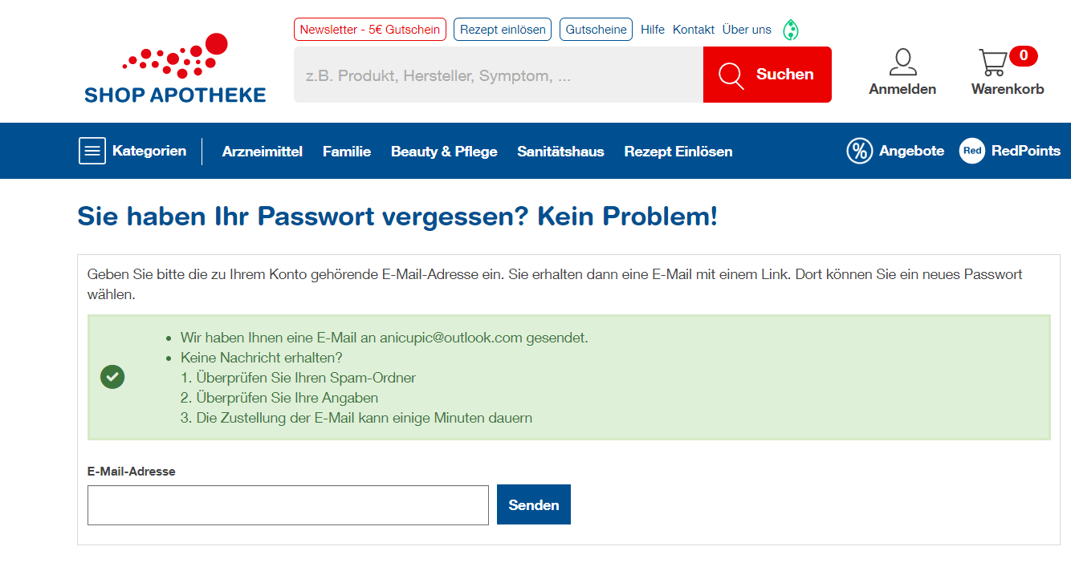On the following screen check if the info message is correct
3. 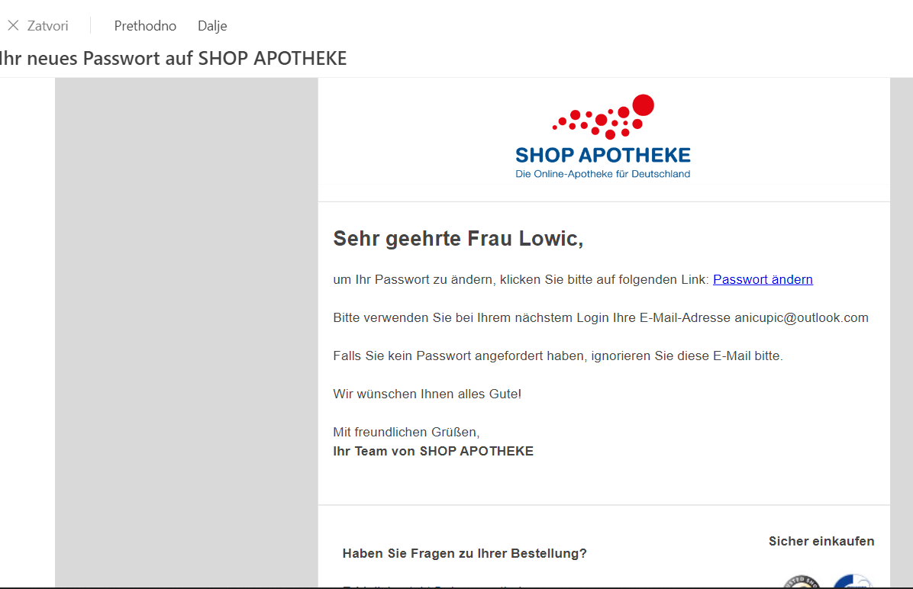Check the E-Mail message and click on the following link “*Passwort ändern”*
4. 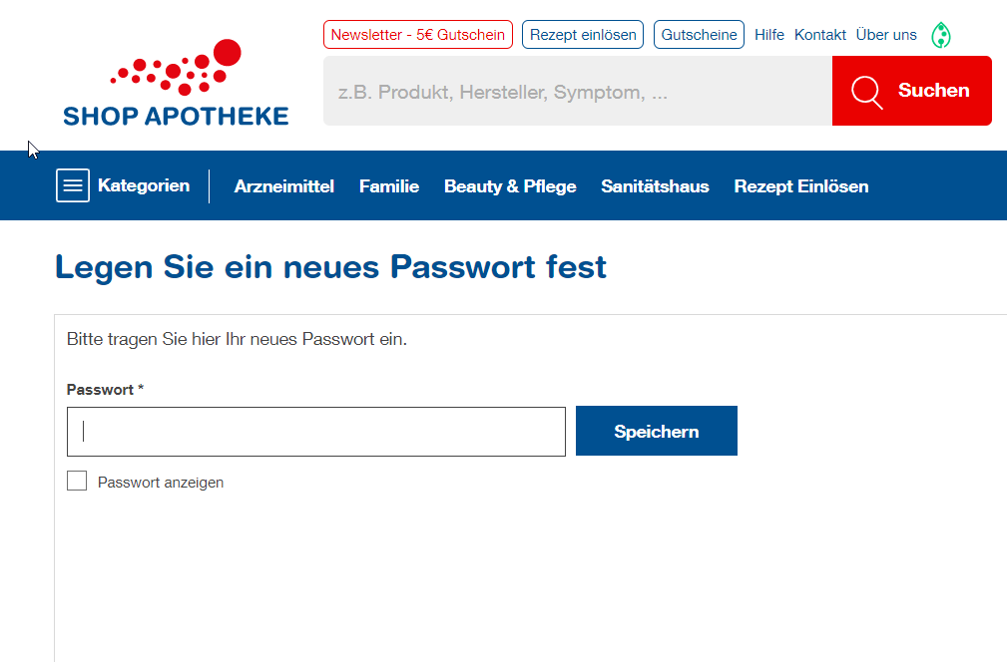User is redictered to the screen for changing the password

# 7.Check if the error message is correct – enter for example 1 Error message should be: “*Bitte prüfen Sie Ihre Eingaben.”*

# When passwort too short, error message is: “*Ihr Passwort ist zu kurz.”*

# 8. Enter now the new passwort and check if the button for “*Passwort anzeigen*” is showing the passwort. Now click on the button “*Speichern*”.

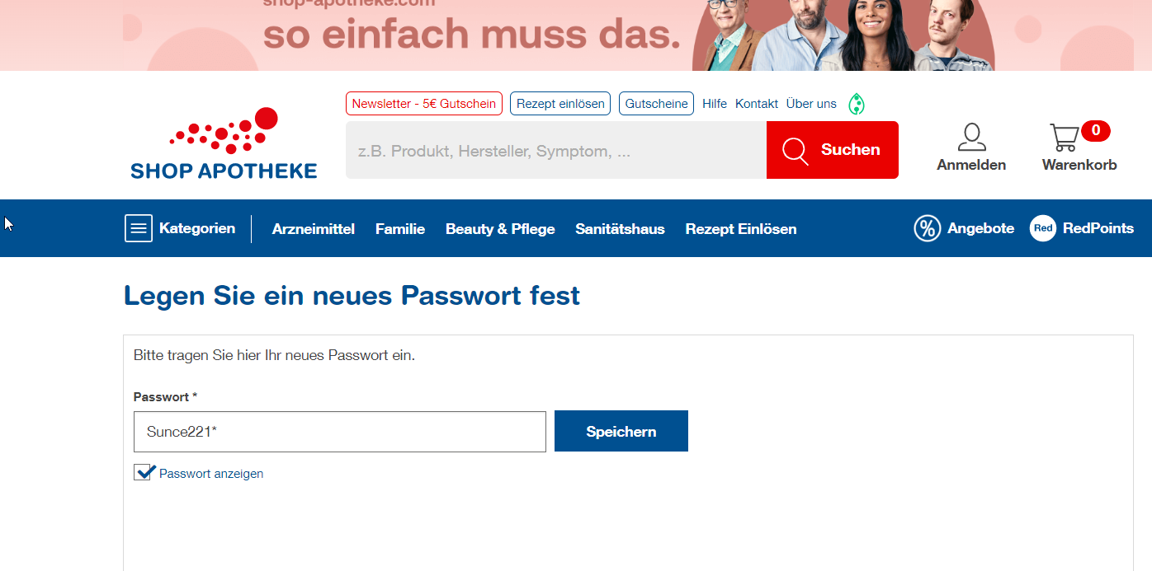

# User is redirected to the Anmelden screen and enter the valid E-Mail and new Passwort

# 

User is successfully logged in.

1. Now log out and login again and check if the login is working correctly.